Test Case: tc005_SPX_Dev5_Crear_Requisicion_Spot_Con_FAD_Tipo_Cobro_Project
Step 1 - Enter username and password and click to button Enter: Credentials Entered
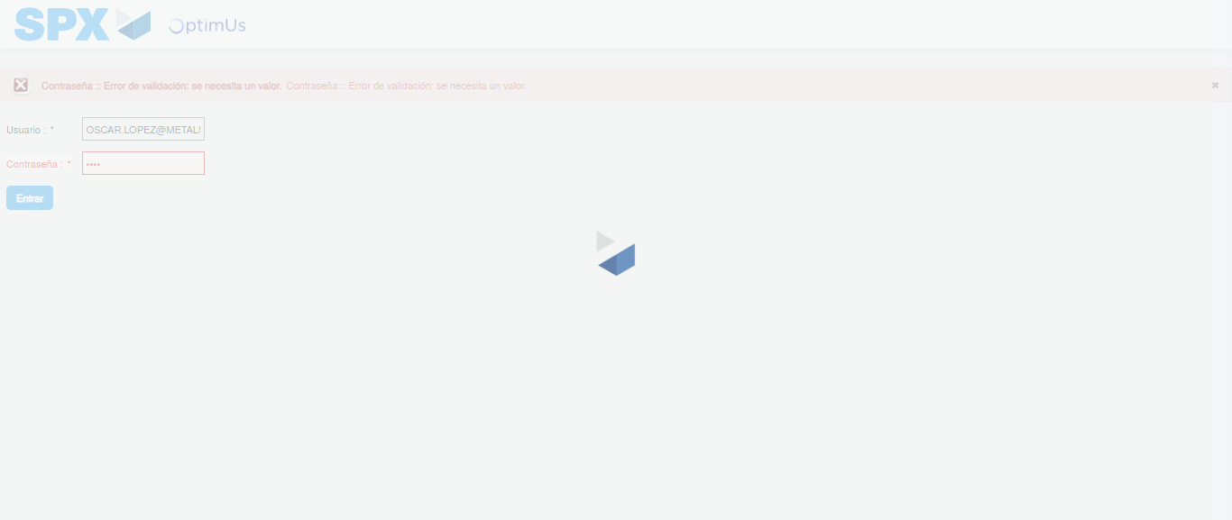Image file-name: QC_Testing-tc005_SPX_Dev5_Crear_Requisicion_Spot_Con_FAD_Tipo_Cobro_Project-1784572404370

Step 2 - Select to UEN and Access to Spot Buy Requisitions : UEN Correctly selected and Correct access
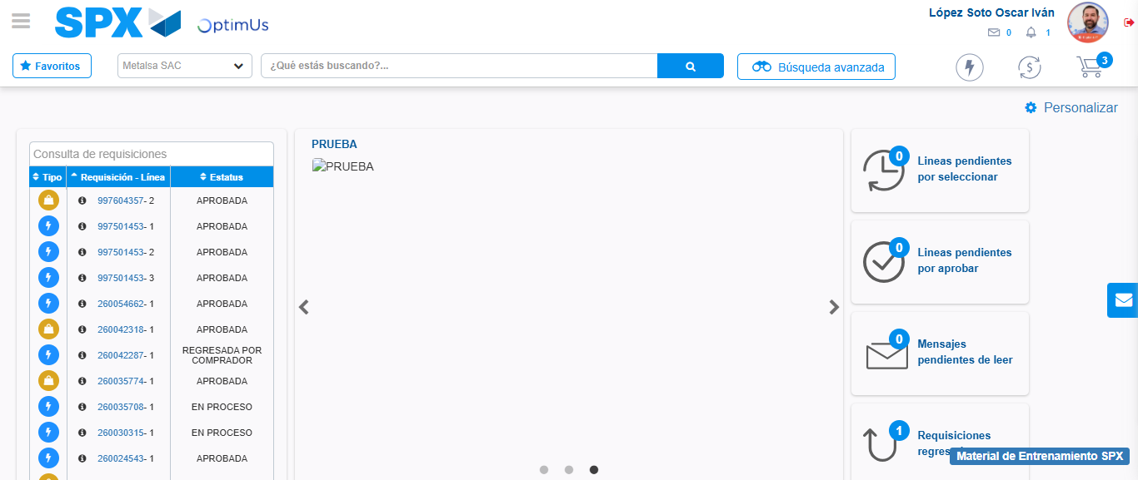Image file-name: QC_Testing-tc005_SPX_Dev5_Crear_Requisicion_Spot_Con_FAD_Tipo_Cobro_Project-1784572471688

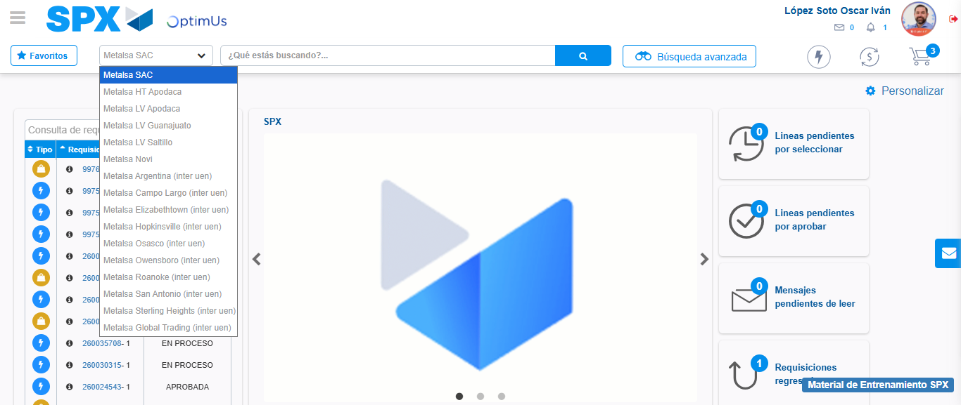Image file-name: QC_Testing-tc005_SPX_Dev5_Crear_Requisicion_Spot_Con_FAD_Tipo_Cobro_Project-1784572474414

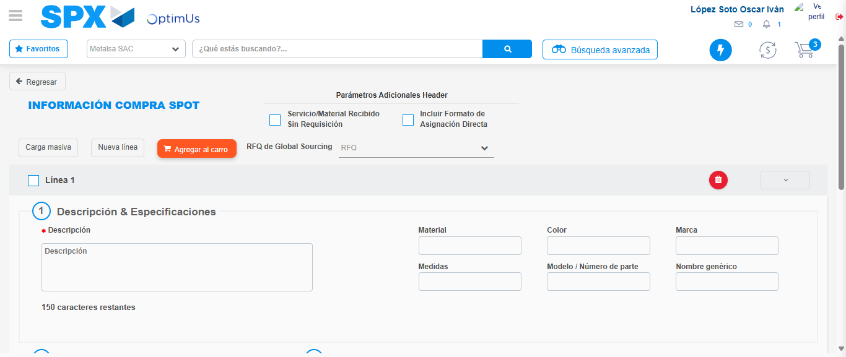Image file-name: QC_Testing-tc005_SPX_Dev5_Crear_Requisicion_Spot_Con_FAD_Tipo_Cobro_Project-1784572485557

Step 3 - Add FAD to Requisition: FAD Successfully Added
Image file-name: QC_Testing-tc005_SPX_Dev5_Crear_Requisicion_Spot_Con_FAD_Tipo_Cobro_Project-1784572485823

Image file-name: QC_Testing-tc005_SPX_Dev5_Crear_Requisicion_Spot_Con_FAD_Tipo_Cobro_Project-1784572486024

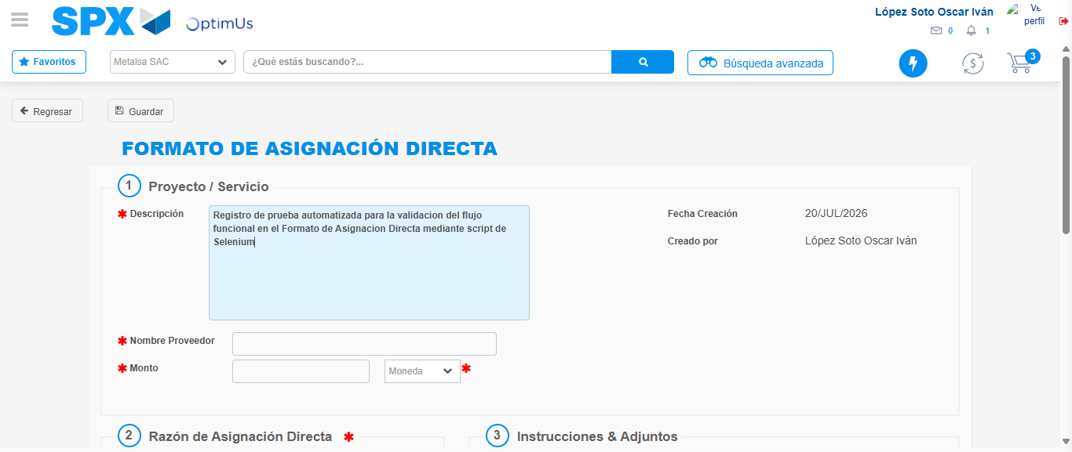Image file-name: QC_Testing-tc005_SPX_Dev5_Crear_Requisicion_Spot_Con_FAD_Tipo_Cobro_Project-1784572488845

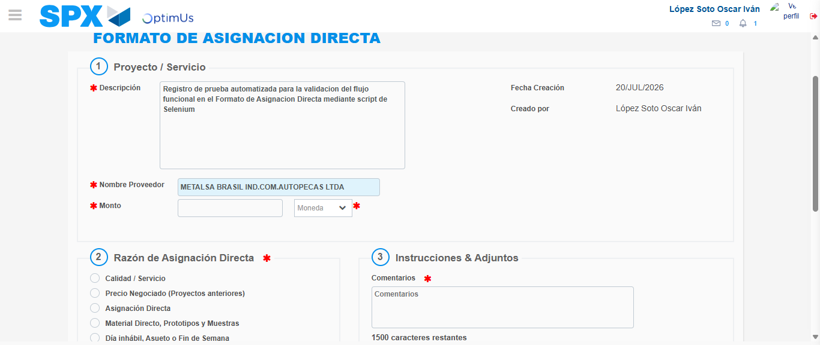Image file-name: QC_Testing-tc005_SPX_Dev5_Crear_Requisicion_Spot_Con_FAD_Tipo_Cobro_Project-1784572494890

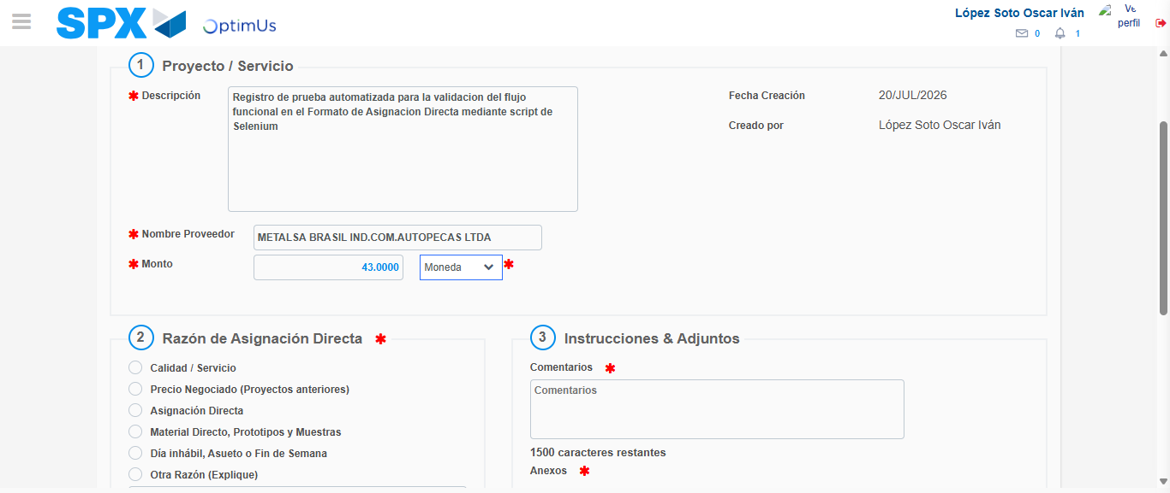Image file-name: QC_Testing-tc005_SPX_Dev5_Crear_Requisicion_Spot_Con_FAD_Tipo_Cobro_Project-1784572495404

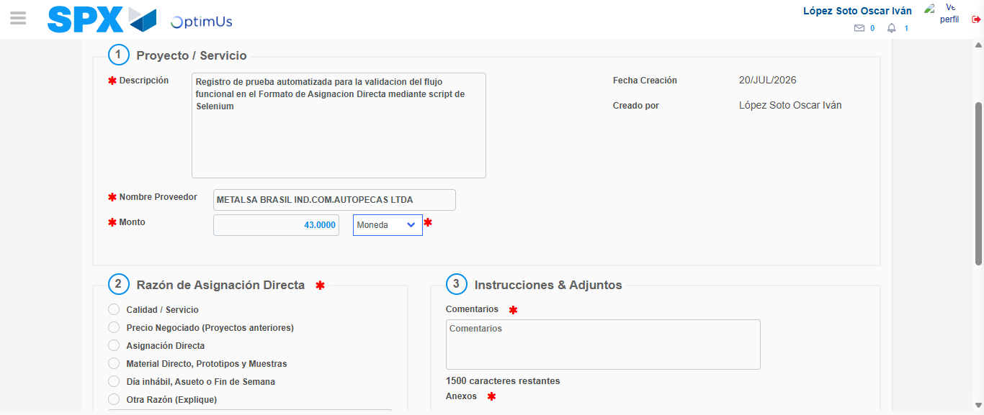Image file-name: QC_Testing-tc005_SPX_Dev5_Crear_Requisicion_Spot_Con_FAD_Tipo_Cobro_Project-1784572495621

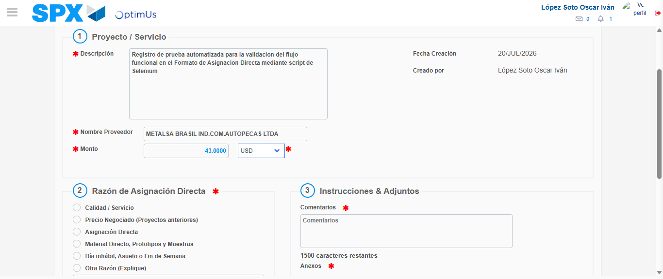Image file-name: QC_Testing-tc005_SPX_Dev5_Crear_Requisicion_Spot_Con_FAD_Tipo_Cobro_Project-1784572495986

Image file-name: QC_Testing-tc005_SPX_Dev5_Crear_Requisicion_Spot_Con_FAD_Tipo_Cobro_Project-1784572496200

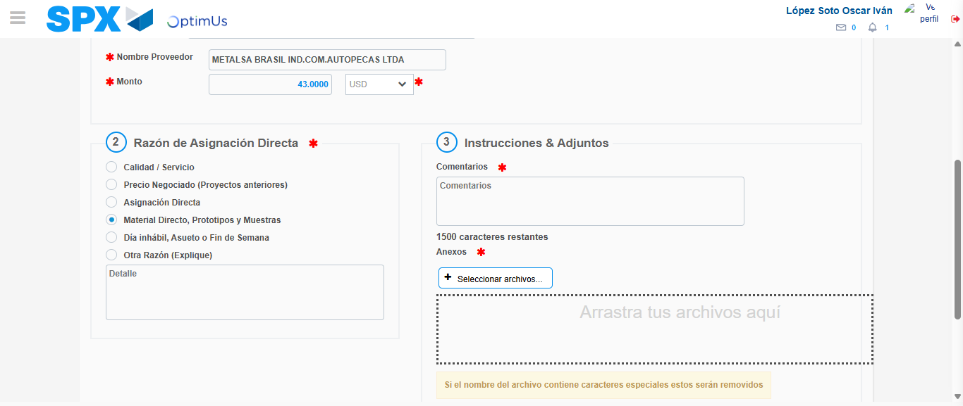Image file-name: QC_Testing-tc005_SPX_Dev5_Crear_Requisicion_Spot_Con_FAD_Tipo_Cobro_Project-1784572497036

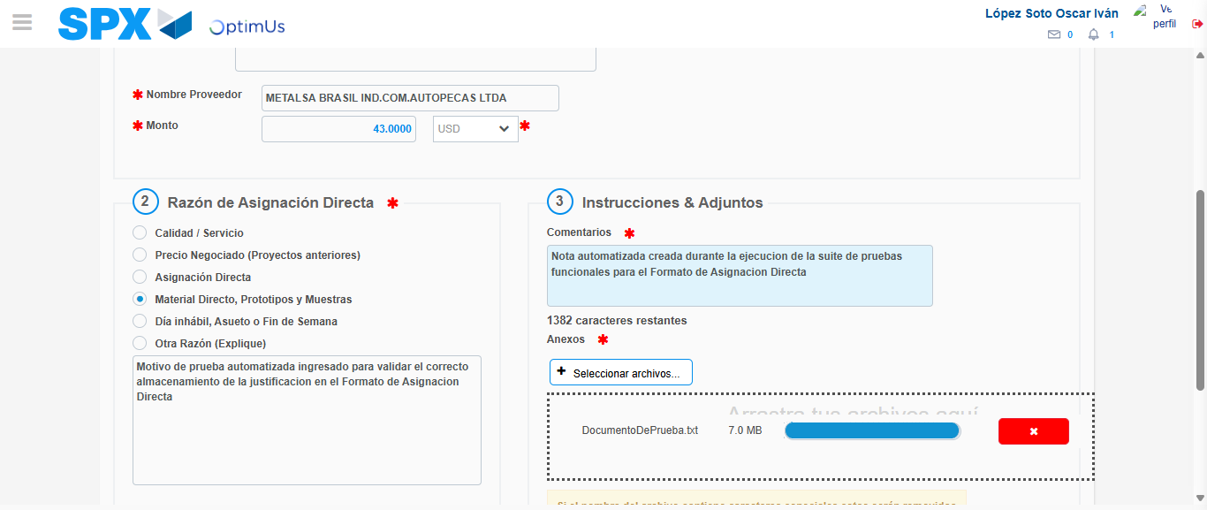Image file-name: QC_Testing-tc005_SPX_Dev5_Crear_Requisicion_Spot_Con_FAD_Tipo_Cobro_Project-1784572508071

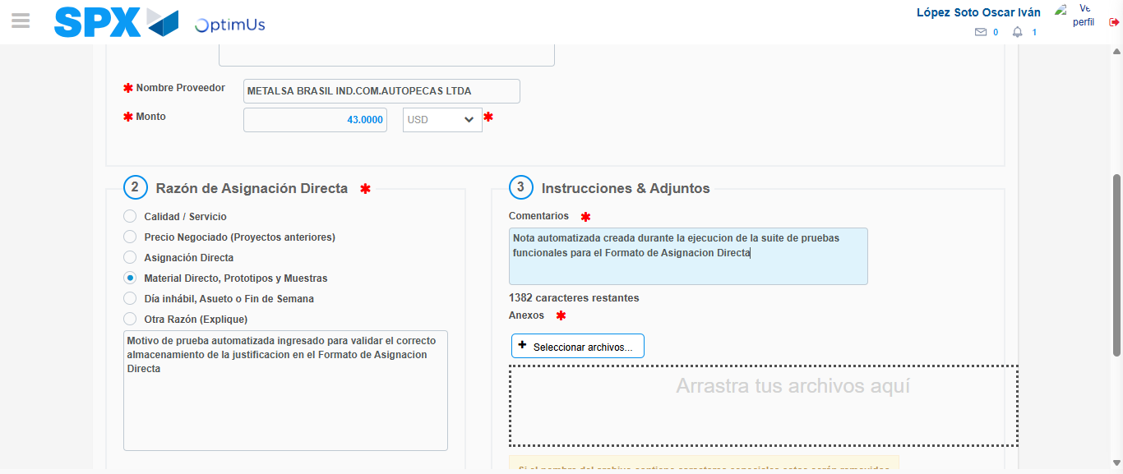Image file-name: QC_Testing-tc005_SPX_Dev5_Crear_Requisicion_Spot_Con_FAD_Tipo_Cobro_Project-1784572509830

Step 4 - Data Capture Spot Buy Requisition: Data captured correctly
Image file-name: QC_Testing-tc005_SPX_Dev5_Crear_Requisicion_Spot_Con_FAD_Tipo_Cobro_Project-1784572485823

Image file-name: QC_Testing-tc005_SPX_Dev5_Crear_Requisicion_Spot_Con_FAD_Tipo_Cobro_Project-1784572486024

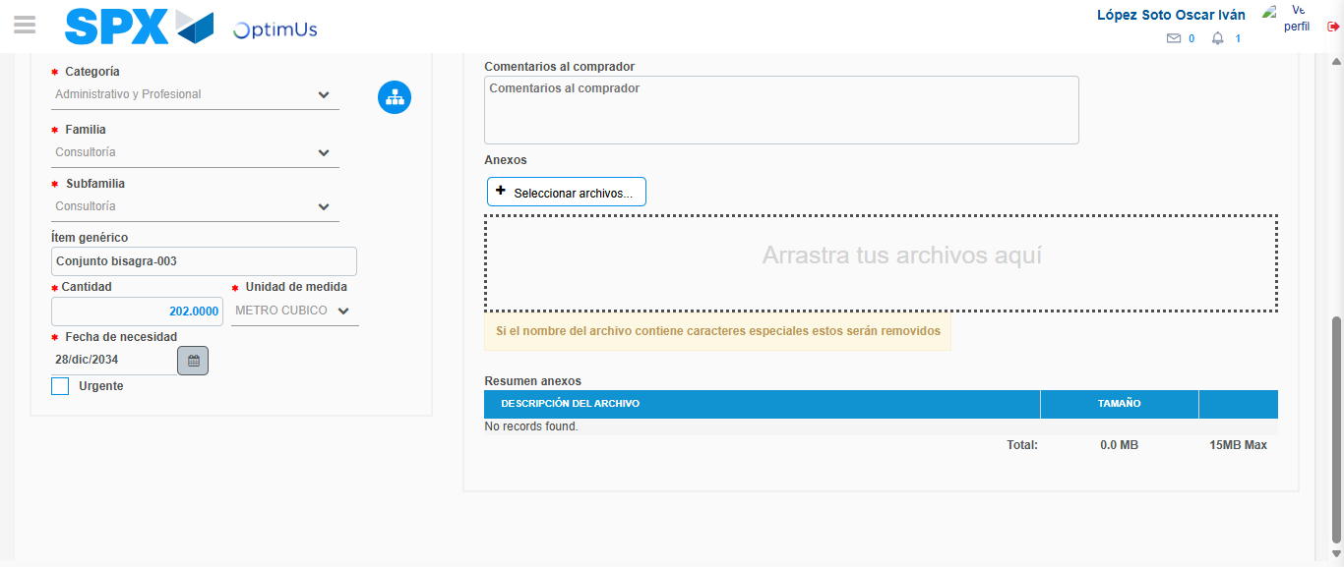Image file-name: QC_Testing-tc005_SPX_Dev5_Crear_Requisicion_Spot_Con_FAD_Tipo_Cobro_Project-1784572524592

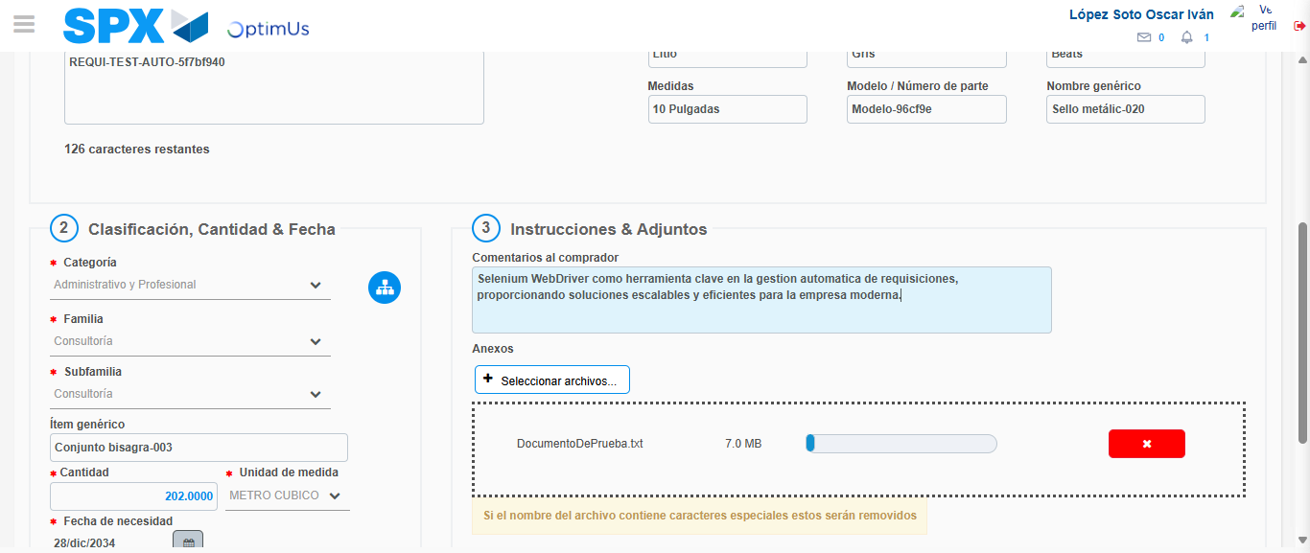Image file-name: QC_Testing-tc005_SPX_Dev5_Crear_Requisicion_Spot_Con_FAD_Tipo_Cobro_Project-1784572525384

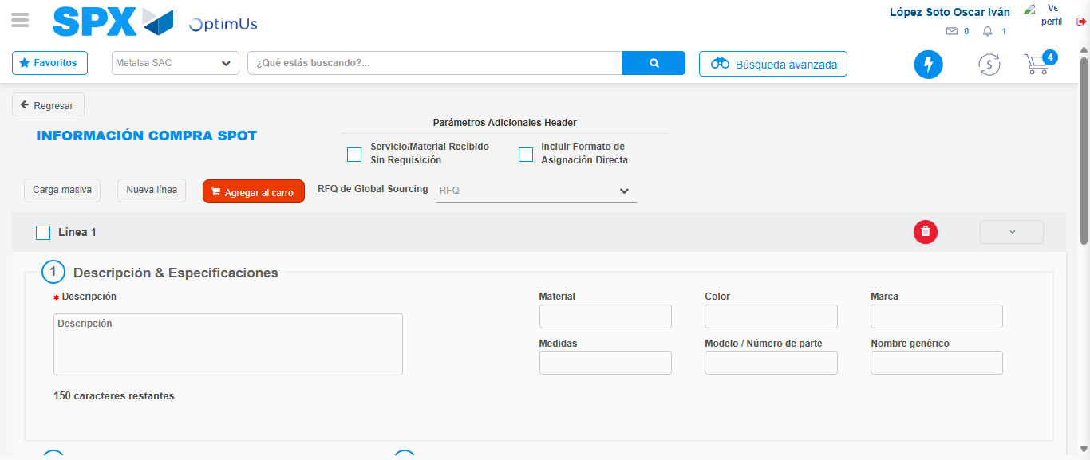Image file-name: QC_Testing-tc005_SPX_Dev5_Crear_Requisicion_Spot_Con_FAD_Tipo_Cobro_Project-1784572531956

Step 8 - Return to Main Page SPX : Return to Main Page SPX
Image file-name: QC_Testing-tc005_SPX_Dev5_Crear_Requisicion_Spot_Con_FAD_Tipo_Cobro_Project-1784572471688

Image file-name: QC_Testing-tc005_SPX_Dev5_Crear_Requisicion_Spot_Con_FAD_Tipo_Cobro_Project-1784572474414

Image file-name: QC_Testing-tc005_SPX_Dev5_Crear_Requisicion_Spot_Con_FAD_Tipo_Cobro_Project-1784572485557

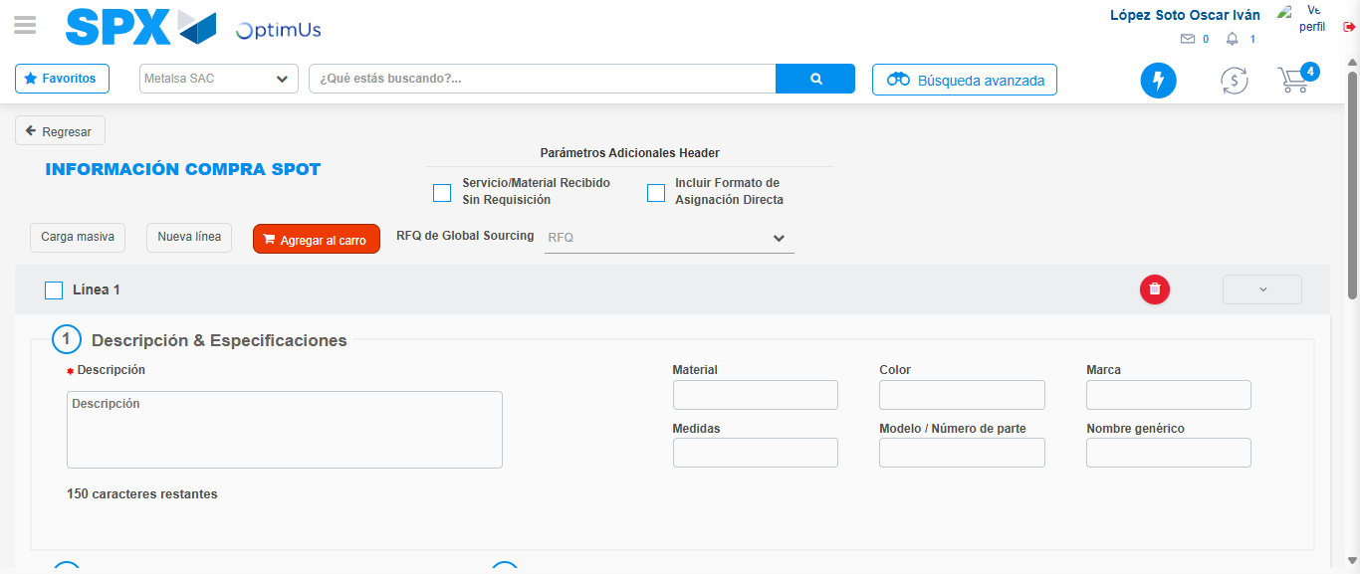Image file-name: QC_Testing-tc005_SPX_Dev5_Crear_Requisicion_Spot_Con_FAD_Tipo_Cobro_Project-1784572534188

Image file-name: QC_Testing-tc005_SPX_Dev5_Crear_Requisicion_Spot_Con_FAD_Tipo_Cobro_Project-1784572534354

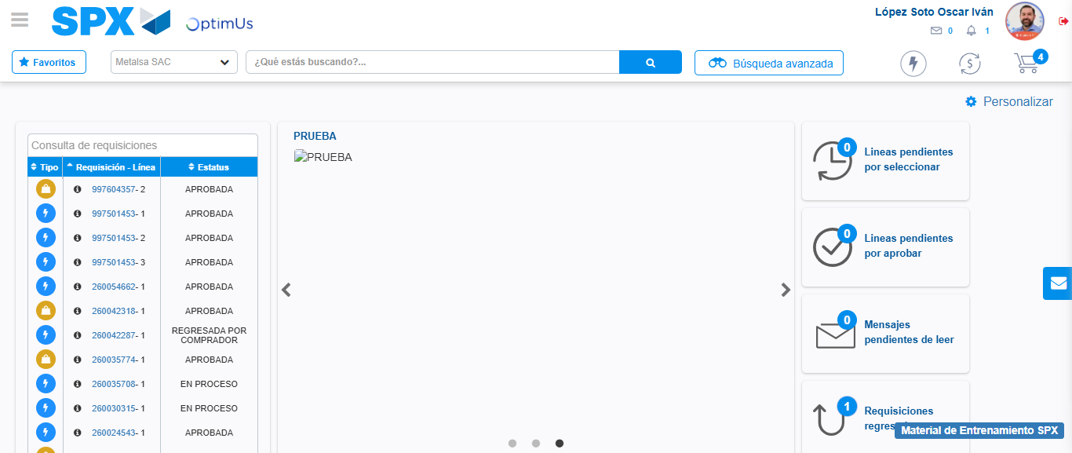Image file-name: QC_Testing-tc005_SPX_Dev5_Crear_Requisicion_Spot_Con_FAD_Tipo_Cobro_Project-1784572556875

Step 9 - Log Out : Log Out SPX
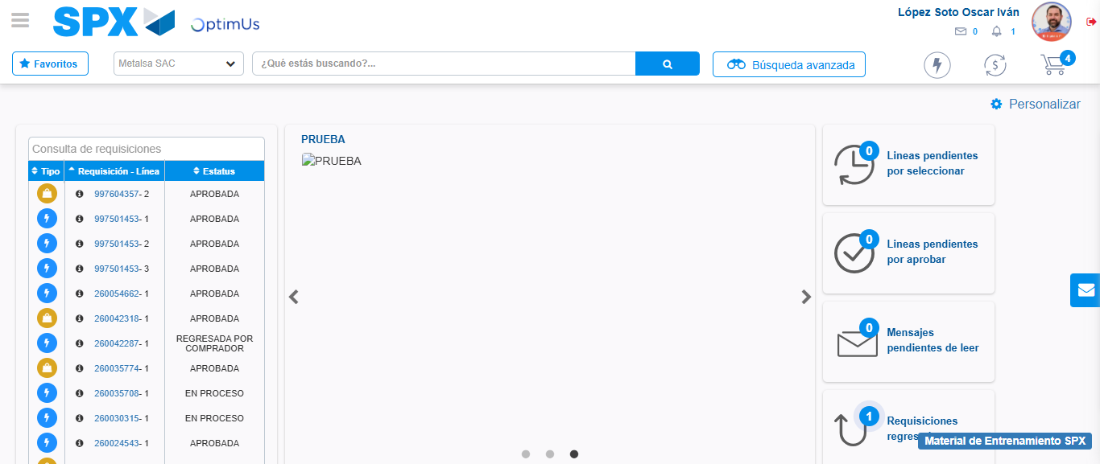Image file-name: QC_Testing-tc005_SPX_Dev5_Crear_Requisicion_Spot_Con_FAD_Tipo_Cobro_Project-1784572557120

